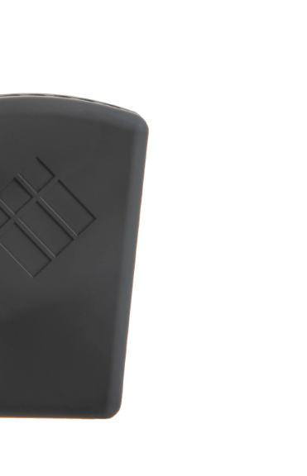

iMO-LEARN
Manual


1. Product Overview

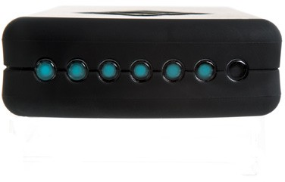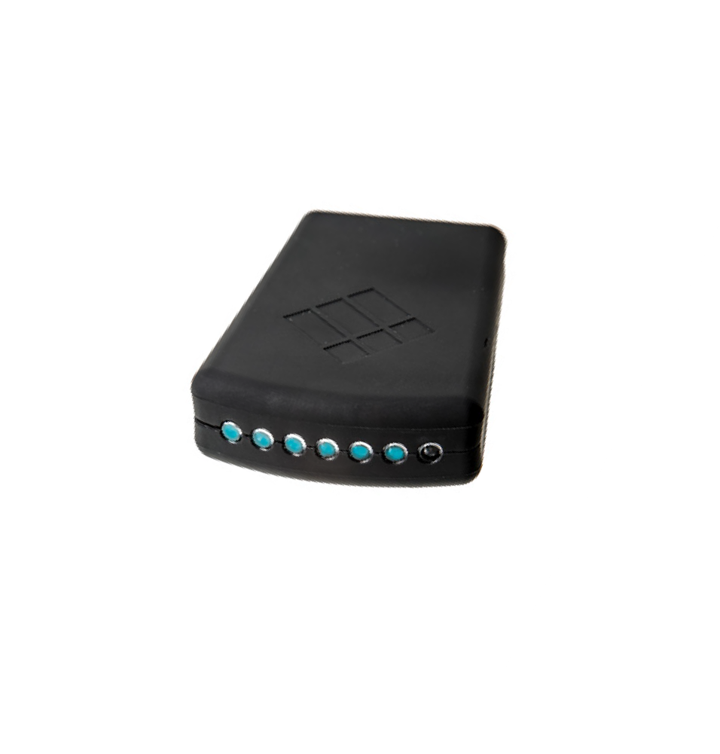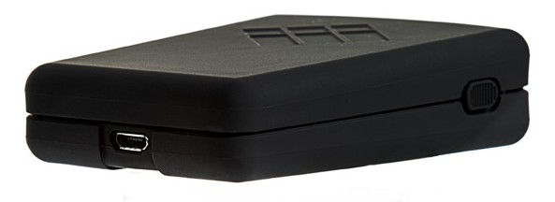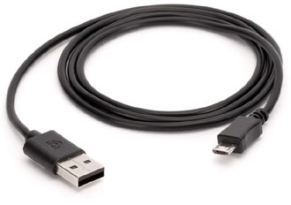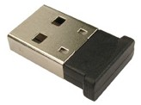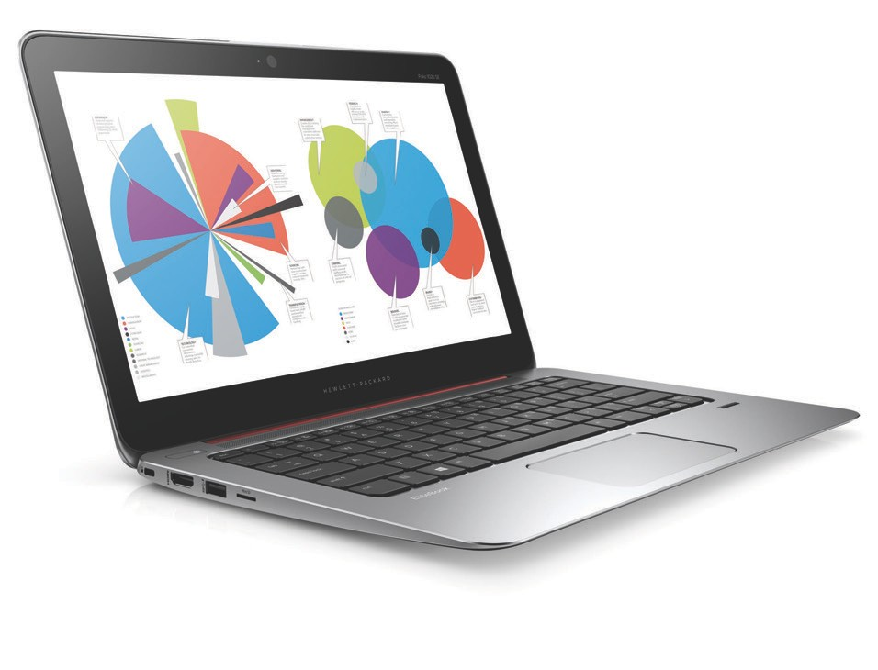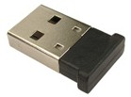
on/off
USB micro
charging port
Status
indicators
Bluetooth
dongle
USB cable
iMO-LEARN
MDM
2. Set Up
Insert the Bluetooth USB Dongle into your computer.

Software Installation

Download & Install
iMO-CONNECT software

https://www.i3-technologies.com
/en/products/hardware/cube-for-active-learning

scroll to the bottom of the page for the download section.


Follow the instructions
of the iMO-CONNECT installer

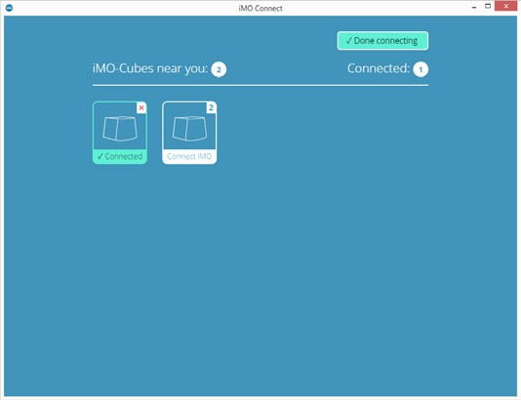


Bluetooth Connection

The status indicators on the iMO-LEARN modules will flash when connected.

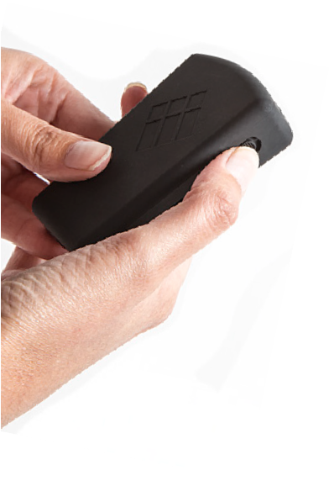
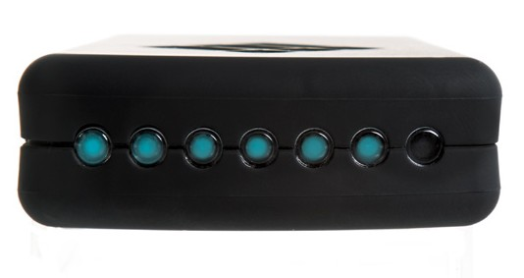
iMO-LEARN Cube
Power ON all the iMO-LEARN
modules.
Open the
iMO-CONNECT
software that will search for the iMO-LEARN modules near you.

Insert the iMO-LEARN MDM in the iMO-LEARN Cube
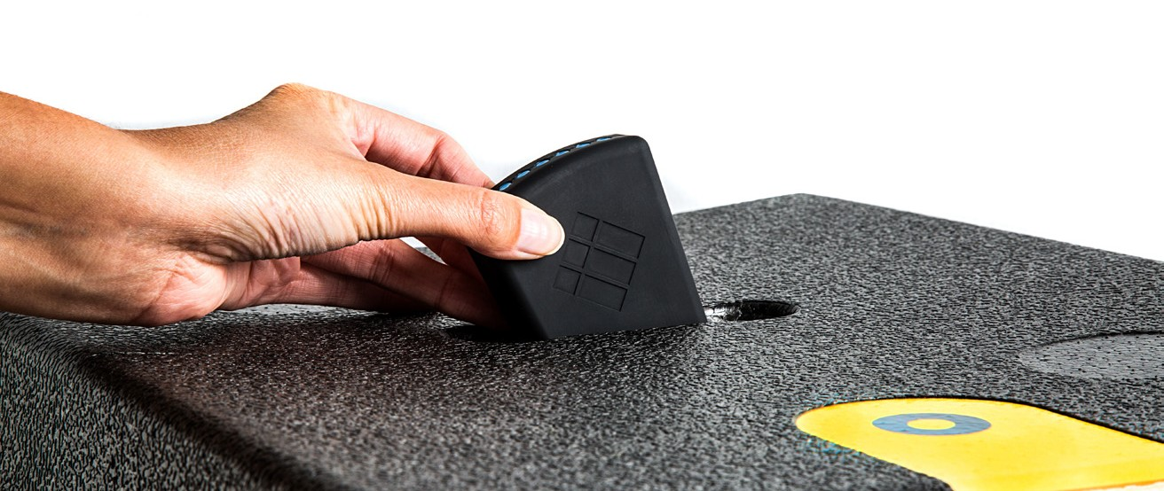
with the i3-logo facing the yellow sticker

Recharging

Recharge the iMO-LEARN MDM with the Micro-USB cable.

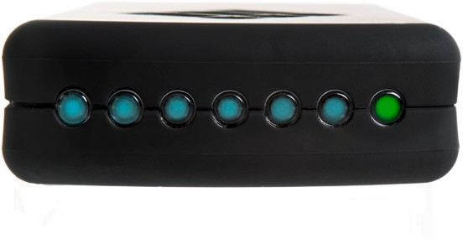
The battery is fully charged when the battery status-indicator is green.
Charging time: 30 minutes.
5V - max 2A

Additional information

Learn more about

iMO-LEARN
on our website.

i3-Technologies NV hereby declares that this iMO-LEARN MDM-100 product is in compliance with the essential requirements and other relevant provisions of the Directives 2014/53/EU, and 2014/65/EU.
The availability of this product may vary by region. This device may contain commodities, technology or software subject to export laws and regulations. Diversion contrary to law is prohibited.





Nijverheidslaan 60, B-8540 Deerlijk, BELGIUM

© 2018 i3-Technologies N.V.
iMO-LEARN, iMO-CONNECT, i3-Technologies and the i3 LOGO are trademarks of i3 GROUP and it’s companies. All other trademarks are the property of their respective owners.

